**Example 1:**

|  |
| --- |
| prefix dc: <http://purl.org/dc/elements/1.1/>  prefix gts: <http://resource.geosciml.org/ontology/timescale/gts#>  prefix skos: <http://www.w3.org/2004/02/skos/core#>  prefix time: <http://www.w3.org/2006/time#>  prefix ts: <http://resource.geosciml.org/vocabulary/timescale/>  prefix isc: <http://resource.geosciml.org/classifier/ics/ischart/>  SELECT DISTINCT ?schemeID str(?label) AS ?geoConcpet ?begTimeValue ?endTimeValue  WHERE  {  GRAPH <http://deeptimekb.org/iscallnew>  {  {  ?tconcept a gts:GeochronologicEra ;  rdfs:label ?label ;  skos:inScheme ?schemeID.  FILTER (lang(?label) = "en")  FILTER strstarts(?label, "Wordian").  ?tconcept time:hasBeginning ?beg ;  time:hasEnd ?end .  ?beg time:inTemporalPosition ?begTime .  ?end time:inTemporalPosition ?endTime .  ?begTime time:numericPosition ?begTimeValue .  ?endTime time:numericPosition ?endTimeValue .  }  UNION  {  FILTER (lang(?label) = "en")  FILTER strstarts(?label, "Wordian").    ?tconcept a gts:GeochronologicEra ;  rdfs:label ?label ;  dc:description  [time:hasBeginning ?beg ;  skos:inScheme ?schemeID].  ?beg time:inTemporalPosition ?begTime .    ?begTime dc:description  [time:numericPosition ?begTimeValue ;  skos:inScheme ?schemeID].  ?tconcept a gts:GeochronologicEra ;  rdfs:label ?label ;  dc:description  [time:hasEnd ?end ;  skos:inScheme ?schemeID].  ?end time:inTemporalPosition ?endTime .  ?endTime dc:description  [time:numericPosition ?endTimeValue ;  skos:inScheme ?schemeID].  }  }  }  ORDER BY DESC (?schemeID) |

**Result：**

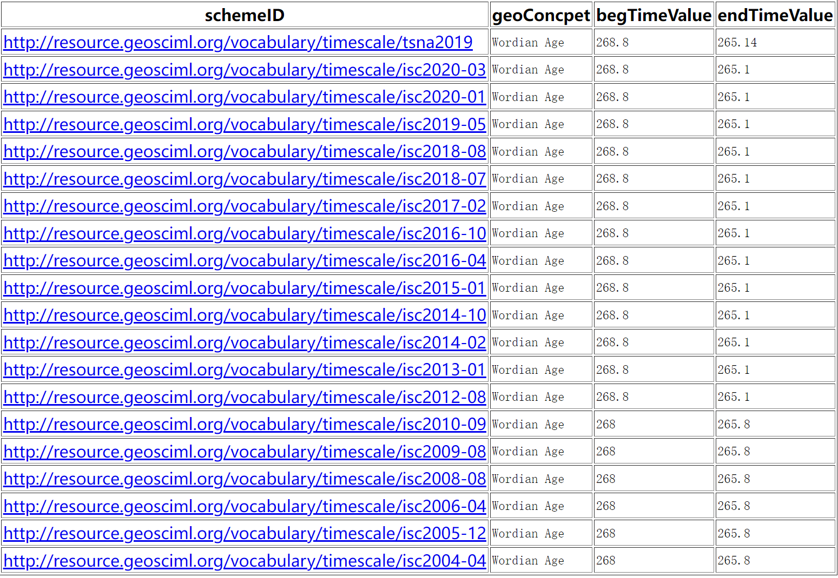

**Example 2:**

|  |
| --- |
| prefix dc: <http://purl.org/dc/elements/1.1/>  prefix gts: <http://resource.geosciml.org/ontology/timescale/gts#>  prefix skos: <http://www.w3.org/2004/02/skos/core#>  prefix time: <http://www.w3.org/2006/time#>  prefix ts: <http://resource.geosciml.org/vocabulary/timescale/>  prefix isc: <http://resource.geosciml.org/classifier/ics/ischart/>  SELECT DISTINCT ?schemeID str (?label) AS ?geoConcept  WHERE  {  GRAPH <http://deeptimekb.org/iscallnew>  {  {  ?tconcept a gts:GeochronologicEra ;  rdfs:label ?label ;  time:hasBeginning ?beg ;  time:hasEnd ?end ;  skos:inScheme ?schemeID.  ?beg time:inTemporalPosition ?begTime.  ?end time:inTemporalPosition ?endTime.  ?begTime time:numericPosition ?begTimeValue.  FILTER(?begTimeValue <= 20 )  ?endTime time:numericPosition ?endTimeValue.  FILTER(?endTimeValue >= 13) .  }  UNION  {  ?tconcept a gts:GeochronologicEra ;  rdfs:label ?label.  ?tconcept dc:description  [time:hasBeginning ?beg;  time:hasEnd ?end;  skos:inScheme ?schemeID].  ?beg time:inTemporalPosition ?begTime.  ?end time:inTemporalPosition ?endTime.  ?begTime dc:description  [time:numericPosition ?begTimeValue;  skos:inScheme ?schemeID].  ?endTime dc:description  [time:numericPosition ?endTimeValue;  skos:inScheme ?schemeID].  FILTER(?begTimeValue <= 20 ).  FILTER(?endTimeValue >= 13 ) .  }  }  } |

**Result：**

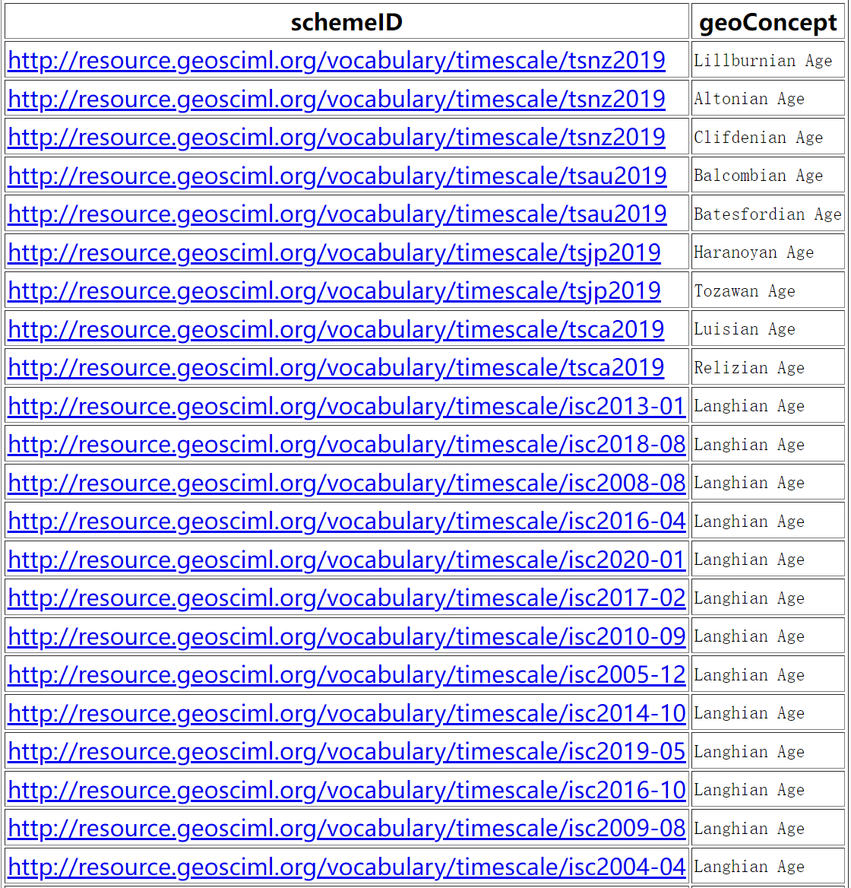

**Example 3:**

|  |
| --- |
| prefix dc: <http://purl.org/dc/elements/1.1/>  prefix gts: <http://resource.geosciml.org/ontology/timescale/gts#>  prefix skos: <http://www.w3.org/2004/02/skos/core#>  prefix time: <http://www.w3.org/2006/time#>  prefix ts: <http://resource.geosciml.org/vocabulary/timescale/>  prefix isc: <http://resource.geosciml.org/classifier/ics/ischart/>  SELECT ?schemeID str (?label) AS ?geoConcept ?begTimeNum ?endTimeNum (?begTimeNum - ?endTimeNum) AS ?duration  WHERE  {  GRAPH <http://deeptimekb.org/iscallnew>  {  {  ?geoconcept rdfs:label ?label ;  dc:description  [  time:hasBeginning ?beg ;  time:hasEnd ?end  ].  ?beg time:inTemporalPosition ?begTime .  ?end time:inTemporalPosition ?endTime .  ?begTime dc:description  [  time:numericPosition ?begTimeNum ;  skos:inScheme ?schemeID  ].  ?endTime dc:description  [  time:numericPosition ?endTimeNum ;  skos:inScheme ?schemeID  ].  FILTER(?endTimeNum <=10)  FILTER(?begTimeNum >= 10)  }  UNION  {  ?geoConcept rdfs:label ?label;  time:hasBeginning ?beg ;  time:hasEnd ?end ;  skos:inScheme ?schemeID .  ?beg time:inTemporalPosition ?begTime .  ?end time:inTemporalPosition ?endTime .  ?begTime time:numericPosition ?begTimeNum .  ?endTime time:numericPosition ?endTimeNum .  FILTER(?begTimeNum <= 10)  FILTER(?endTimeNum >= 10)  }  }  }  ORDER BY ?schemeID |

**Result：**

